readmeCV.txt

This note describes the basic controlled vocabulary provided in the file "baseCV.txt" and the program "CheckVsCV" that checks a definition against a controlled vocabulary.
If there are any questions about this program, send a note to Patrick Cassidy:
cassidy@micra.com
Be sure to include the word ‘Vocabulary’ in the subject header, so that the message will not get lost in the spam.

The basic Controlled vocabulary contained in the file baseCV.txt is a list of words inspired by the controlled defining vocabulary used by the Longman's Dictionary of Contemporary English (also called LDOCE. Longman Publishers Ltd., London: http://pewebdic2.cw.idm.fr/). The starting list was taken from an on-line listing of the Longman's controlled vocabulary. Longman uses a basic vocabulary of about 2000 words (these are the base forms, and some have multiple senses). Several other dictionaries also used similar controlled vocabularies. With these words the Longman lexicographers are able to define all of the 64,000 words in their dictionary. One purpose of using a controlled vocabulary is to create definitions that will be comprehensible to learners of the English language whose native language is not English. The same principle can be used to help specialists in one field to understand the terms and concepts used by specialists in other fields. That is, there is a fundamental inventory of words (and concepts) of tractable size that is adequate to describe the meanings of many other, more specialized terms and concepts. This principle can be adapted to permit developers of vocabularies for different Communities of Interest (COIs) to define their vocabularies so as to be comprehensible to people in other COIs.

The list of words in baseCV.txt is provided as a starting "Controlled vocabulary" that can be used by builders of domain taxonomies, thesauri, and ontologies to define the meanings of the terms they are formalizing in their Knowledge Organization Systems (KOSs). In addition to the basic vocabulary in the baseCV.txt, we anticipate maintaining an expanded vocabulary that is still common to many communities, called the supplementedCV.txt. The supplemented vocabulary will have words in addition to those in the baseCV.txt, but those additional words will have been edefined using the words in the baseCV.txt (or, will be defined using both terms in the baseCV.txt and other words in the suppementedCV.txt). In additikonb, it is anticipated that, within each COI, these basic vocabularies will also be supplemented aith a community-specific vocabulary, which will be rapidly expanded as new terms are added, each new term defined by using the terms in the basic vocabularies existing at that time. Eventually the richer COI controlled vocabulary will develop, itself containing many specialized terms. By starting with the basic COI-neutral vocabulary, and by defining all new terms by using the existing terms in the Controlled vocabulary, all terms in each resulting Controlled Vocabulary will be recursively defined by reference to the basic terms understood in all communities. By using a controlled vocabulary for definitions, builders of community KOSs can achieve two useful effects: (1) the definitions are likely to be comprehensible to people who are not specialists in the same area of knowledge as is described in the COI vocabulary; and (2) the definitions will be more easily formalized to create precise meanings for terms that can be used for automated inferencing by computer systems having logic-based reasoning capability.

The basic vocabulary baseCV.txt may itself be supplemented, or may in fact be reduced from time to time if it is found possible to define terms that are in the baseCV.txt using only terms in that vocabulkary – but a term can only be "promoted" to the supplementedCV.txt if there are no other terms in the baseCV.txt that use the newly defined term in their definitions. At present, definitions for all of the terms in the baseCV.txt are not available, so it is not possible yet to start the process of examining terms in the baseCV.txt to determine if they can be defined and promoted out into the supplementedCV.txt.

This controlled vocabulary is provided as a tool for those who would like their COI KOSs to be comprehensible outside their own specialized communities. It is not to be interpreted as a straightjacket that will constrain the range of words that can be used in definitions. Checking a proposed definition of a COI term against the COI controlled vocabulary will serve as a warning to the domain knowledge expert that the proposed definition may use terms in specialized senses that could be misunderstood by those outside the COI. Whether the undefined term being used in a definition will be used without being itself defined, or whether the domain knowledge expert will take the time to write a definition for that term, using the pre-existing COI vocabulary, is a decision that the knowledge-enterer must make. How to use a COI controlled vocabulary, whether or not it is based on a basic controlled vocabulary such as the one provided here, will be for each COI to determine by its own criteria.

A simple JAVA-based utility program is provided that will check whether the words in a proposed definition are all contained in the community controlled vocabulary. In the event that words are found in a definition that is not in the COI vocabulary, there are several possible responses:

(1) the missing word may be a lexical variation of one of the common words in the base Controlled vocabulary (in the file baseCV.txt). Such words will inevitably be found, as the starting file "baseCV.txt" was created by automated procedures that did not include all possible variant forms of a word. Such words may be ignored. Notifying us (e.g. e-mail pcassidy@mitre.org) of the defect will be appreciated.

(2) the missing word seems to be a common word, but is not in the baseCV.
There will be many such cases. In most cases, there will be a synonymous word in the baseCV, and if there is, it is simplest to use that word in place of the word originally used in the definition. If there is no word in the base CV that is quite synonymous with the common term one want to use, it is best to create a definition of that term using words in the baseCV (consulting Longman's on-line (http://pewebdic2.cw.idm.fr/) to find how they would define it might help). In this case, it would again be appreciated if we were notified of this apparent missing word, as it may be one that should be included in the community-neutral baseCV.
One virtue of defining the term for use in the COI vocabulary, rather than just adding it without a definition, is the possibility that that term, though common, may be used in slightly different senses in different communities. This is valuable information that can eventually be useful for development of programs that can extract information from texts in different COI document bases. Notifying us of the need to define even common terms will be appreciated, and will help advance the common need for interoperability among COI knowledge bases.
The COI knowledge expert may choose to ignore the fact that that word is not in the COI controlled vocabulary, and use it anyway. We would still appreciate being notified of the need for this term in definitions.

(3) The missing term is used in a special sense in the COI.
This is the case where defining the term by use of the pre-existing terms in the COI controlled vocabulary will be of great benefit. By providing such definitions, the comprehensibility of documents outside of a COI (and for novices in the field) should be improved.

(4) In general, when a new term is added to the COI controlled vocabulary, the vocabulary custodian should also add all of the lexical (morphological) variants, such as plural forms (for nouns), past, past perfect, gerundive (-ing) , and third-person singular (for verbs), and adverbial forms (e.g. by adding a –ly suffix) for adjectives Some other forms created by use of prefixes or suffixes such as un- or –ness, may also be deemed necessary.

We will also appreciate having such definitions, created using the basic Controlled Vocabulary or any recursively defined derivative of it, recorded on the ONTACWG Wiki page for such supplementary definitions:
http://colab.cim3.net/cgi-bin/wiki.pl?CosmoWG/SupplementalVocabulary

To use the controlled vocabulary will entail some additional effort initially, as terms not in the baseCV must be added to generate the broader vocabulary in common use within the COI. This burden should lessen rapidly as the COI vocabulary becomes more complete with domain terms.

Vocabulary-check Utility

The program CheckVsCV is a very simple Java program that allows one to paste a definition into the program frame, test it against a controlled permitted word list, and if there are any words not on the list, the definition itself can be modified, or the controlled word list may be supplemented. But the word-list (the COI controlled vocabulary) supplementation takes place outside the program itself, in whatever word processor the user prefers. This program has only been tested under Windows XP using JAVA 1.4.2.

The program checkVsCV is not a spelling-checker, and does not provide any suggested alternative words, nor does it have any interface with other programs other than the potential to copy and paste among programs in a GUI environment. The source code is provided and if any part is useful, it can be adapted as desired by individual COIs.

The program is provided as a JAVA executable ".jar" file, together with the JAVA source and the basic controlled vocabulary suggested as a common starting point for all COIs. The starting controlled vocabulary "baseCV.txt" is the default vocabulary that the program assumes, but the name can be changed in the interface. The default must be changed by changing the program and recompiling it. All program-related files must be in the same directory (the controlled vocabulary file can be elsewhere, in which case a fully qualified path must be used for the filename).

The program can be executed by clicking on the executable ".bat" file provided, or by typing in the command "CheckVsCV" in a command window. The initial screen is depicted below:

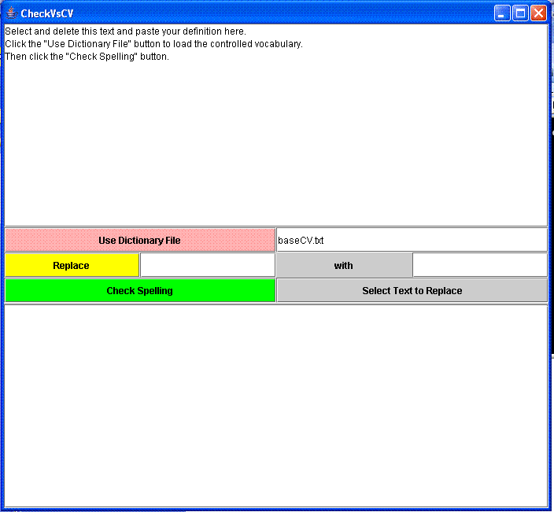

Usage:
(1) Select and delete the starting text in the top window and paste the proposed definition in that window.
(2) Load the Controlled Vocabulary by typing the name of the Controlled vocabulary file (full path if it is not in the same directory as the program) and then pressing the "Use Dictionary File" button.
(3) Press the "Check Spelling" button.
(4) If any words in the proposed definition are not in the Controlled vocabulary file (or are present in a different case), a pop-up window will specify the unrecognized word and give the option to ignore it or halt the checking process.

(4.1) If a word is merely in the wrong case for some formatting reason (as are the words "Check" and "Spelling" in the text show in the starting window), a user will probably want to ignore that, and will press the "Ignore" button on the pop-up and go on to the next unrecognized word. When there are no more unrecognized words, the pop-ups will stop.

(4.2) If a word is unrecognized and is not merely a variant of a word already in the controlled vocabulary, and if the user does not wish to use a synonymous word in the definition, it is suggested that a definition be created for the new vocabulary word, using the terms already in the Controlled Vocabulary.
In this case, we request that you send the new definition by email to Patrick Cassidy:
cassidy@micra.com

(4.3) If the user wishes to change a word in the definition window, it can be done using the typical editing functions in that window, or by typing the word in the "Replace" field, and the replacement word in the "With" field, and then pressing the "Replace" button. This action will replace the first occurrence of that string in the proposed definition. If the string occurs more than once (e.g. as part of a larger word), then after typing the string in the "replace" field, click the "Select Text To Replace" button, and continue clicking it until the location is highlighted where the string to e replaced is located. Then click the "Replace" button.

(5) A different Controlled vocabulary can be loaded without closing the program window. The check against the controlled vocabulary will be done against whatever text is present in the top field at the time the "Check Spelling" button is clicked. The check can be done any number of times without reloading the Controlled Vocabulary.

(5.1) To check whether a single word is in the controlled vocabulary, one can select and cut the text in the window, type in that word, do the check, and then re-paste the original text back into the test window.

(6) Some potentially informative information will be written to the lower report window, which serves as a log of the session, after certain operations.

(7) The program is terminated by closing the window.

